Food Processing
Food processing, any of a variety of operations by which raw foodstuffs are made suitable for consumption, cooking, or storage.
Food processing generally includes the basic preparation of foods, the alteration of a food product into another form (as in making preserves from fruit), and preservation and packaging techniques
Introduction
1. The product needs to be safe to consume for the duration of its shelf-life (under appropriate storage conditions). This means that the processing step needs to inactivate microorganisms that are responsible for spoilage, or, alternatively, create an environment where bacterial growth is inhibited. For example, heating inactivates many microorganisms and drying creates an environment where bacterial growth is inhibited as the water activity (the water that’s accessible to bacteria) is too low.
2. The quality of the raw product must be maintained or enhanced during processing. With fresh produce, this means preserving the health-promoting qualities of the raw materials, such as conserving vitamin C during the production of orange juice.
3. Processing must take account of sustainability both in terms of the resources consumed during the operations, and in minimising waste by reducing deterioration at all stages of the supply chain as well during storage.
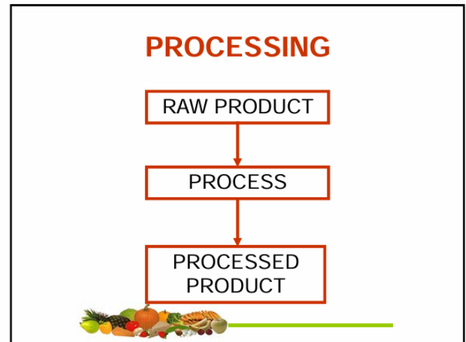
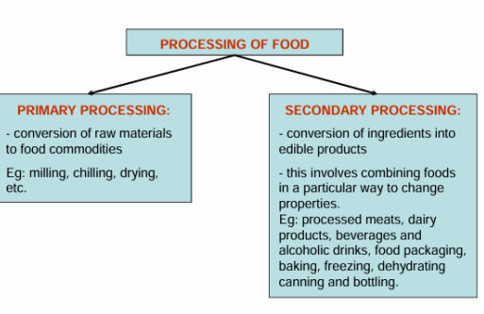
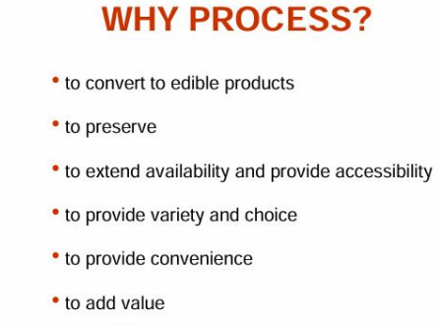
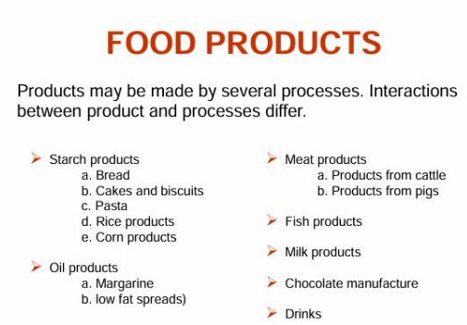
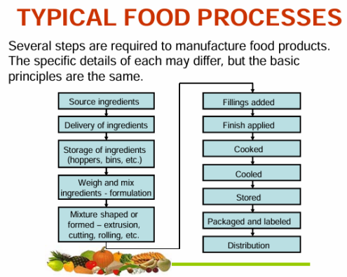
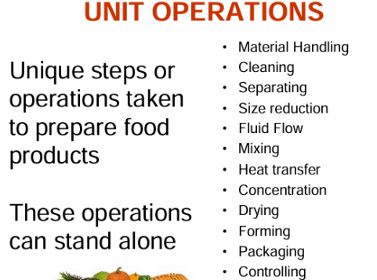
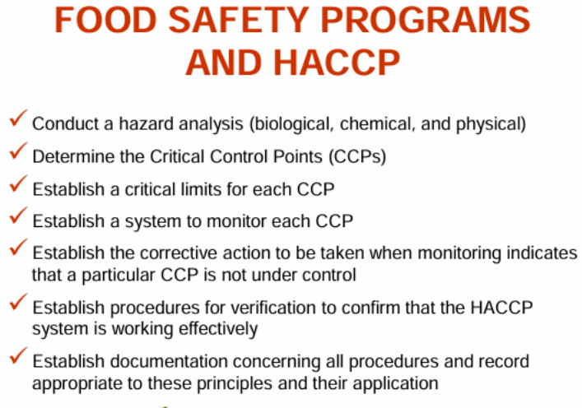

Good Manufacturing Practices in the Food Industry
Good Manufacturing Practices (GMPs) in the food industry are guidelines and principles implemented to ensure food safety and quality. GMPs cover all aspects of food production, from receiving raw materials to finished product shipment.
GMPs include guidelines on personnel hygiene, plant sanitation, equipment maintenance, product labelling, and record-keeping. These guidelines help prevent contamination, crosscontamination, and the introduction of foreign substances into the food supply.
Benefits
Compliance with GMP guidelines is essential for businesses involved in the food industry, and the benefits of adhering to these GMP regulations are numerous.
One of the most significant benefits of GMP compliance is that it helps to ensure that food products are safe for consumption. The guidelines cover everything from the cleanliness of the facility to the handling of ingredients and finished products. By following these guidelines, businesses can minimize the risk of contamination and ensure that their products are safe for consumption.
GMP compliance can also improve efficiency. By following standardized processes and procedures, businesses can streamline operations, reduce waste, and minimize errors, helping reduce costs and increase profitability.
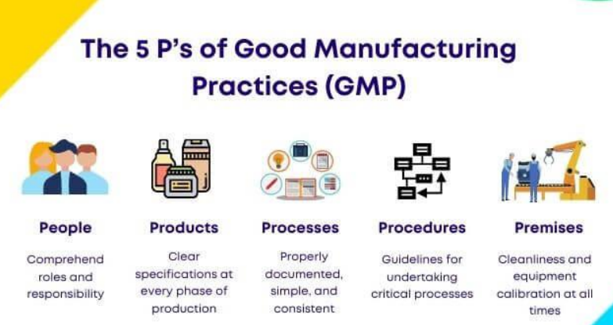
Some of the most essential GMP requirements in food manufacturing include:
- Quality Management
Quality management is essential to ensure the proper execution of the food manufacturing process. The process entails verifying that all food items meet the necessary quality criteria. The standards involve testing raw materials, monitoring production processes, and conducting final inspections.
- Sanitation and Hygiene
Maintaining a hygienic environment throughout the food production facility is necessary to prevent contamination. Part of the protocol involves routine cleaning and disinfecting of surfaces, equipment, and utensils. Also, maintaining personal hygiene is crucial for food handlers to ensure safe food handling practices.
3. Pest Control
Pest control is necessary to ensure food safety and adhere to GMP standards. The process requires preventing pests such as rodents, insects, and birds in the food production area. Effective pest control includes the proper storage of food products to avoid infestation. It’s necessary for all surfaces that come in direct contact with food to be free of pests to prevent any contamination.
4. Suitable Facility Location
The ideal location for the facility should be free from contamination and pollution, and the facility should be designed for minimal risk in food manufacturing operations. It should also be easy and convenient for cleaning and maintenance.
5. Equipment
The design of the equipment used in food manufacturing should minimize potential errors and be appropriate for its intended use. All food-contact surfaces should be easy to clean and maintain.
6. Raw Materials
The quality of production materials must meet specific standards and be stored, handled, and utilized to prevent the risk of contamination of the final product. Suppliers and food ingredients must meet safety and quality specifications.
7. Product Labelling
All food products must have accurate and complete labeling containing relevant information. The required information comprises the product name, identity, net weight or measure, and the name and address of the food manufacturer or distributor. All food products must have a list of ingredients and any allergens present.
8. Storage and Transportation
Storing and transporting all food products under appropriate conditions is necessary for safety and quality. Food safety entails maintaining proper temperatures for food products (especially those that are considered Time and Temperature Control for Safety or TCS food), preventing contamination, and safeguarding against physical, chemical, and biological threats.
9. Personnel
Employees play a significant role in food safety. So, it’s necessary for all individuals who handle food to receive adequate training in food safety and good manufacturing practices. Individuals also need to be knowledgeable about potential hazards that may arise during food production.
10. Validation and Verification
It’s crucial to trace, verify, and validate all food safety procedures, which involve testing raw materials, monitoring production processes, conducting final inspections, and keeping records of all food safety activities. This process is essential to ensure the final product is safe for consumption. 11. Documentation and Record-Keeping.
Proper documentation of food safety procedures is necessary. It includes recording raw materials, production processes, final inspections, and food safety activities. Documentation ensures compliance with safety procedures and enables prompt corrective action in case of any issues.
12. Inspection and Auditing
Government agencies require food manufacturing to undergo regular inspections. These inspections help ensure the facility complies with all food safety regulations. Additionally, third parties often audit certifications to verify compliance.
Good Agricultural Practices (GAP)/Good Horticultural Practices (GHP)
- Soil Management
- Seed
- Use of Fertilizers
- Planting
- Pest and Disease Management
- Use of Pesticides
- Irrigation
- Harvesting and post-harvesting
Good Agricultural Practices (GAP), Example: Soybean
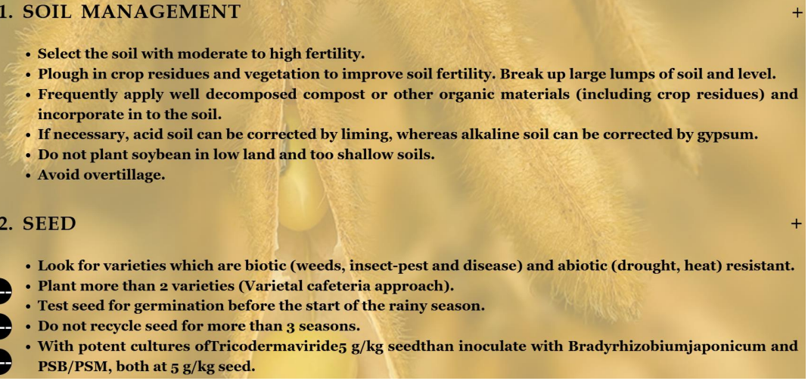
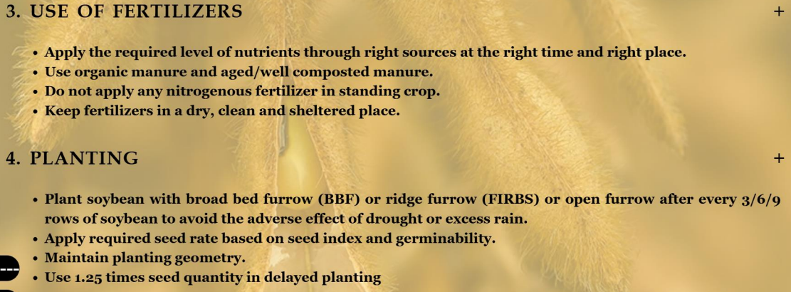
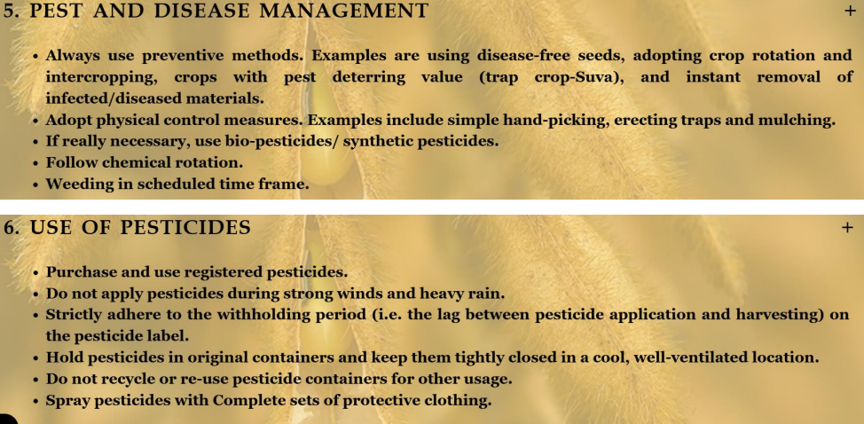
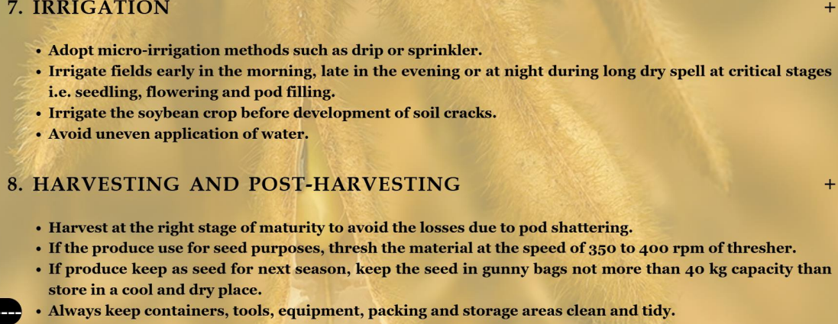
Good Laboratory Practices (GLP)
Good Laboratory Practices are defined by the Organization for Economic Cooperation and Development (OECD) as a set of rules and criteria for quality systems concerned with the organizational process and the conditions under which non-clinical health and environmental safety studies are planned, performed, monitored, recorded, reported, and archived. GLP should be seen as a high-quality standard that ensures assay performance in a very organized and consistent manner for the results to be reliable. It must be followed to maintain dependably high standards and comply with internal company procedures, any regulations set by government agencies, and international regulations.
Test facilities such as laboratories conducting studies for submission to regulatory bodies adhere to the OECD Principles of Good Laboratory Practice. These studies aim to evaluate the health and environmental safety of chemicals and chemical products, including those of natural or biological origin. In some instances, these substances may also encompass living organisms. They also include the work conducted in greenhouses and for the agrochemical sector.
GLP is applied in the pharmaceutical industry, but not exclusively, as GLP applies to the non-clinical safety testing of items contained in pesticide products, cosmetics, veterinary drugs, food additives, and industrial chemicals. Specific studies include toxicity and mutagenicity assays, water, soil, and air behavior, bioaccumulation, and studies to determine chemicals residues in food or animal feedstuffs.
Standard Operating Procedures (SOPs)
SOPs are step-by-step instructions from any organization to help workers carry out routine tasks. These procedures ought to be well-documented and readily available to every team member. Beyond just guidelines, there should also be forms or documents for data registration. These records must be uniform, straightforward, thorough, signed by those who fulfilled them and dated.
2. Data recording
All the data belonging to the study should be captured and included in records that are safely stored. All data generated during the studies under GLP should be recorded directly, promptly, accurately, and legibly by the individual entering the information. These entries should be signed or initiated and dated. These data include the type of test, how it was performed (protocol and standard operating procedures), the dates, and who oversaw achieving it. Standard laboratory notebooks should be used, and data should be entered into computers in the correct format in checked paper format or with validated and compliant software for laboratory data entry.
3. Correct use of equipment
Equipment used in a study should be periodically inspected, cleaned, maintained, and calibrated according to standard operating procedures and under GLP certified providers. Records of these activities should be maintained and registered, too. Calibration should, where appropriate, be traceable to national or international measurement standards.
Tested items
4. Chemicals, reagents, and solutions should be labeled to indicate identity (with concentration if appropriate), expiry date, and specific storage instructions, including temperature, light/darkness, and humidity. Information concerning the source, preparation date, and stability should be available. The expiry date may be extended based on documented evaluations or analysis.
5. Staff and training
Only staff qualified to carry out testing procedures should do so. Staff should understand their role and have a job description. Records of staff qualifications and training and development should be kept. A preclinical research study is usually overseen by a Study director responsible for the study results. It is their role to check that the correct practice is followed and to sign off on the Protocol of the study and the Final report, including the results at the end of the study.
6. Facilities
The test facility should be suitable in size, construction, and location to meet the study's requirements and minimize disturbance that would interfere with its validity. The design of the test facility should provide an adequate degree of separation of the different activities to ensure the proper development of each study and avoid cross-contamination.
7. Audit and Inspections
Routine checks, internally and externally, are essential to ensure compliance with the abovementioned practices and identify any required adjustments. The internal inspections examine the research standard procedures (SOPs) Protocols and how results are reported. Internal audits prepared the staff and the lab for external audits. External audits are carried out by regulatory agencies such as the European Medicines Agency (EMA) and the Food and Drug Administration (FDA).
Best Aquaculture Practice
BAP is the first comprehensive aquaculture certification program with a global presence to be recognized by the Global Sustainable Seafood Initiative (GSSI) and the Global Food Safety Initiative (GFSI).
BAP is administered by the Global Aquaculture Alliance (GGA), a non-profit organization dedicated to the promotion, education and leadership in responsible aquaculture.
BAP includes the entire aquaculture production chain from farms to processing plants, as well as hatcheries and feed factories; it also addresses environmental and social responsibility, animal welfare, food safety and traceability of aquaculture facilities.

